LINUX –

Linux is a free, open-source operating system that powers everything from smartphones and servers to the internet. It's a versatile and reliable alternative to Windows or macOS, known for its security, flexibility, and customization options. 

In summary, the primary purpose of Linux is **to provide a powerful, flexible, and cost-effective computing platform that can be customized and adapted to meet the specific needs of users, developers, and organizations**.  
Linux is used in the following ways: **Server OS for web servers, database servers, file servers, email servers and any other type of shared server**. Designed to support high-volume and multithreading applications, Linux is well-suited for all types of server applications. Desktop OS for personal productivity computing.  
In short,  
Linux is an operating system that **powers a wide range of devices today, including supercomputers, cars, smartphones and most of the internet**. It serves as a free, open-source system that is updated and maintained by a global community of users.  
  
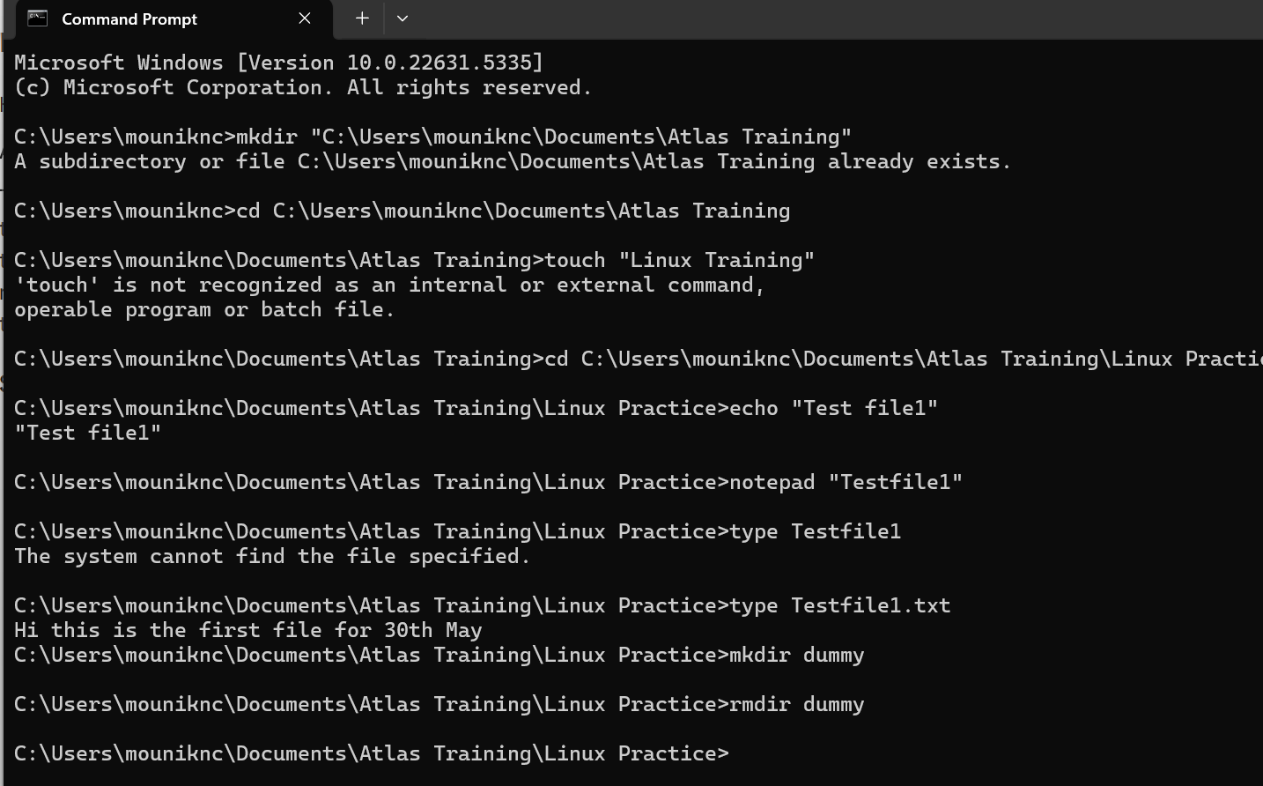

Create dummy folder

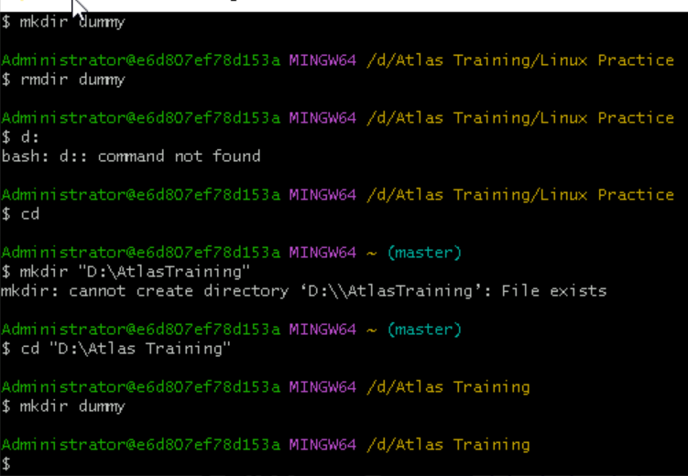

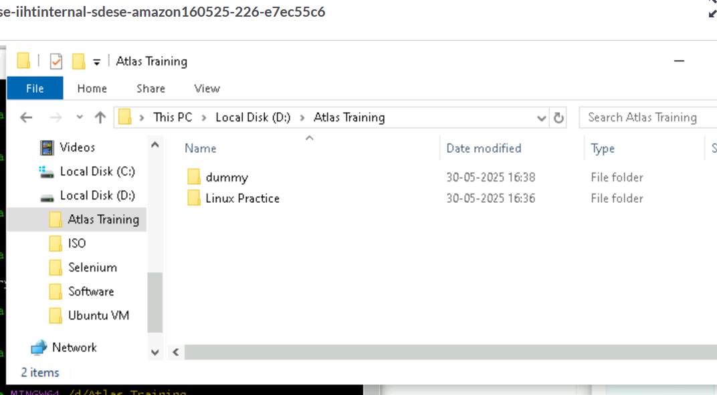

Create files

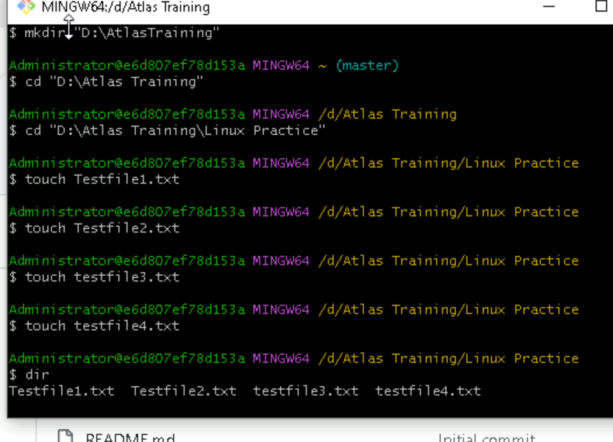

Delete Dummy

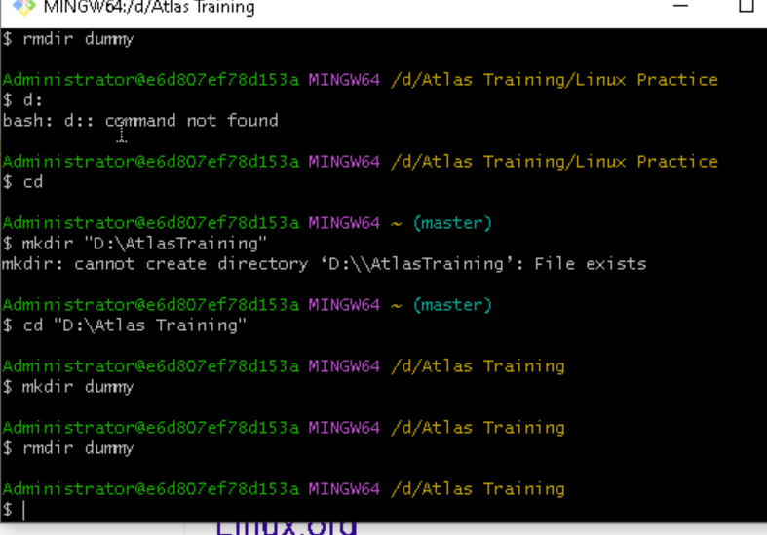

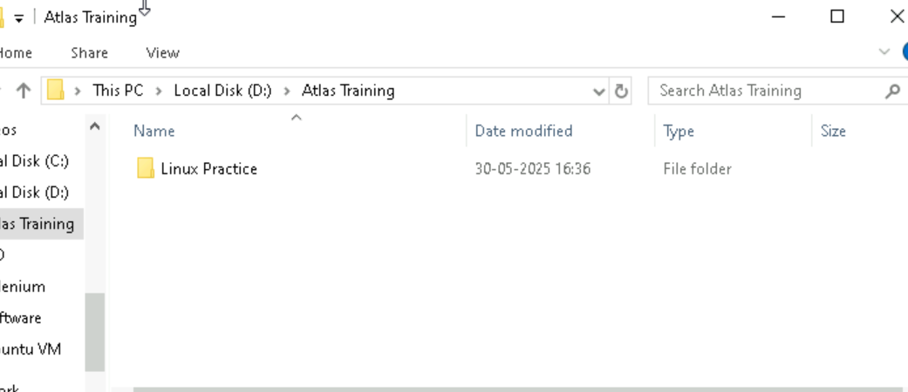

Copy form 1 directory to other directory   
  
cp -r “directory(files present)”/* destinatiin directory/  
  
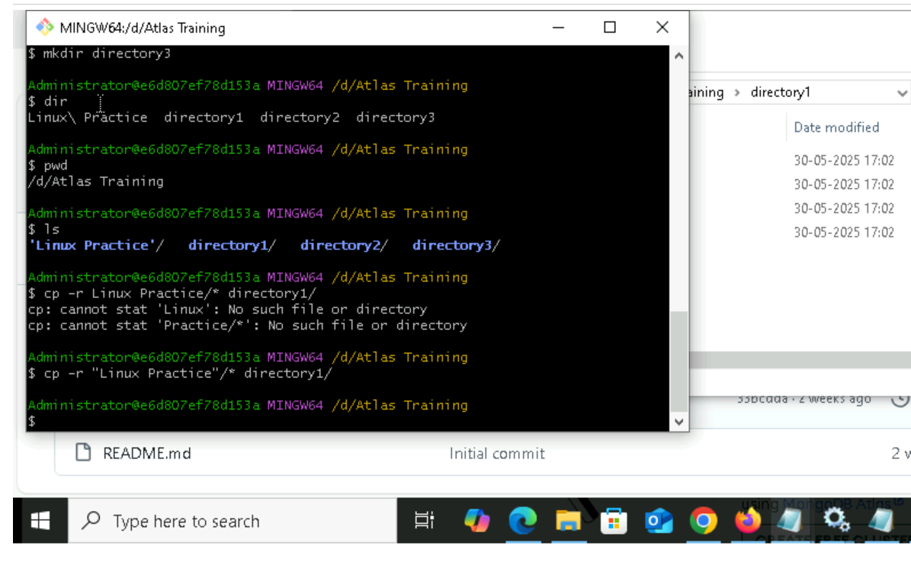

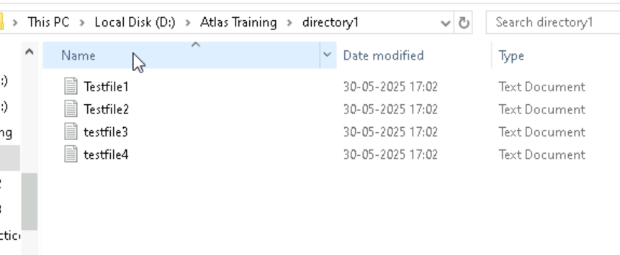

Move from one directory to other directory

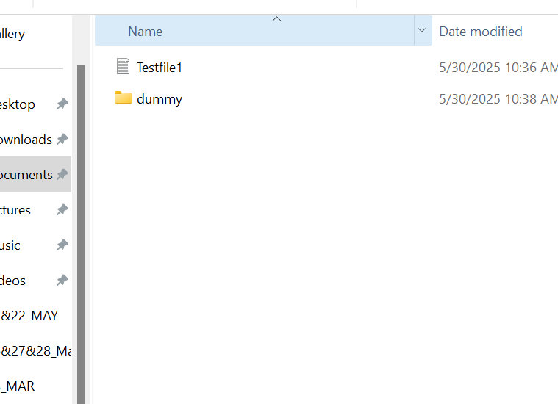

rmdir

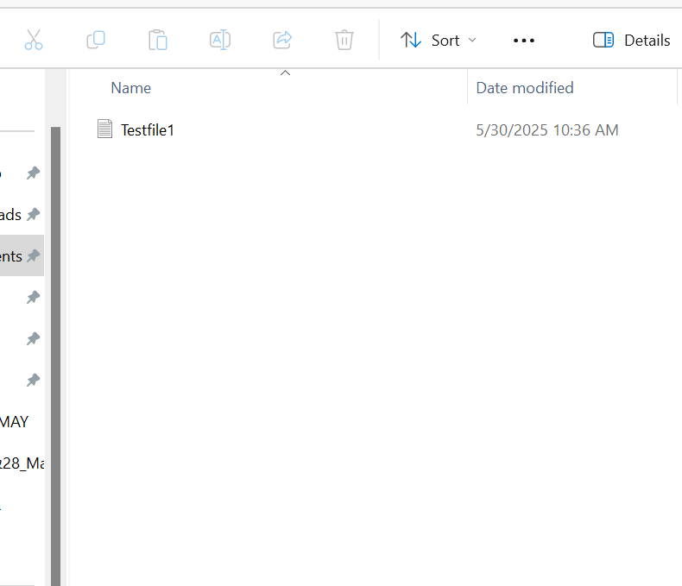

Move form one directory to other

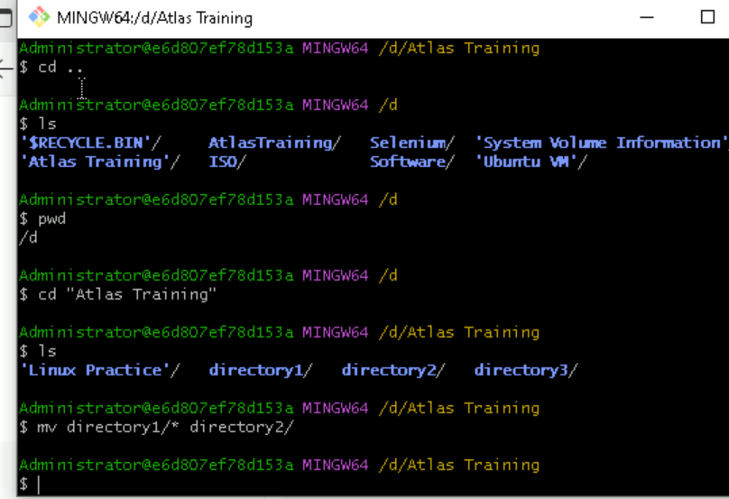

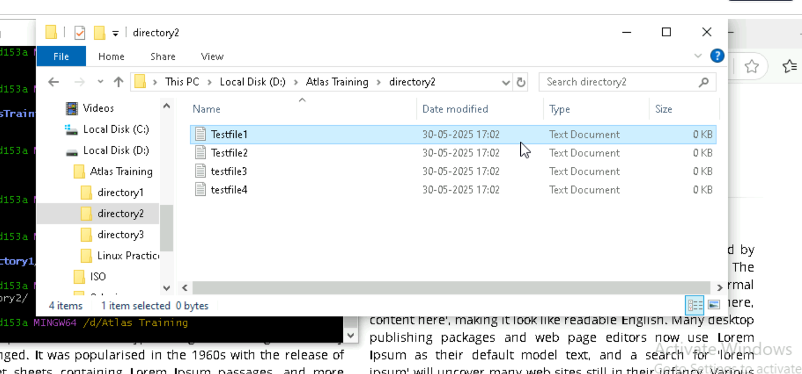

More

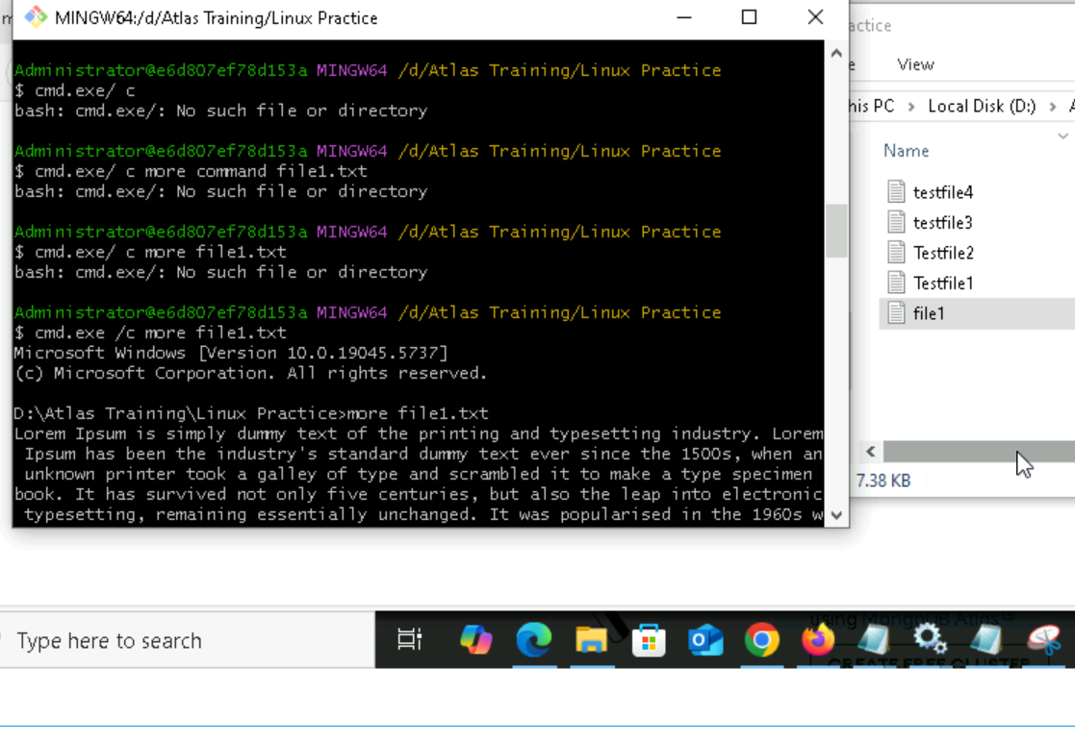

Echo

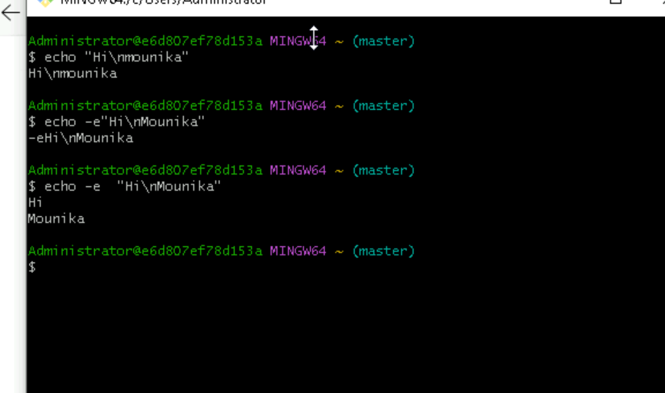

Ubutnu installed  
  
whoami

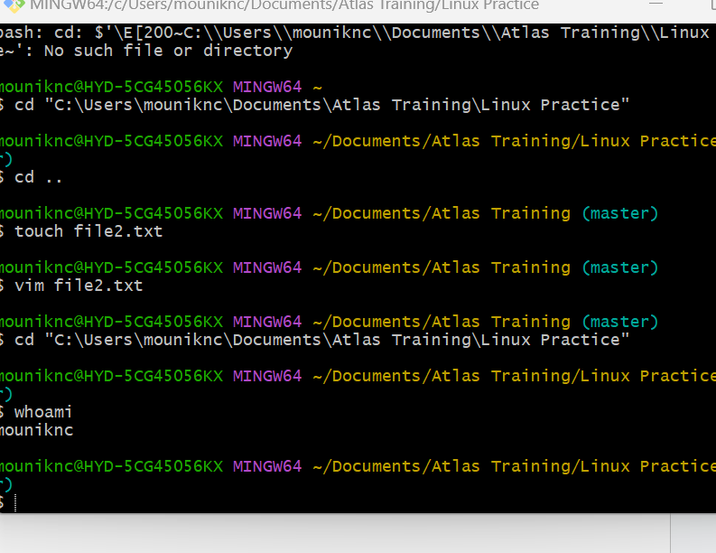  
  
touch – create file & add content  
cat – create & content  
echo – add content & create file  
  
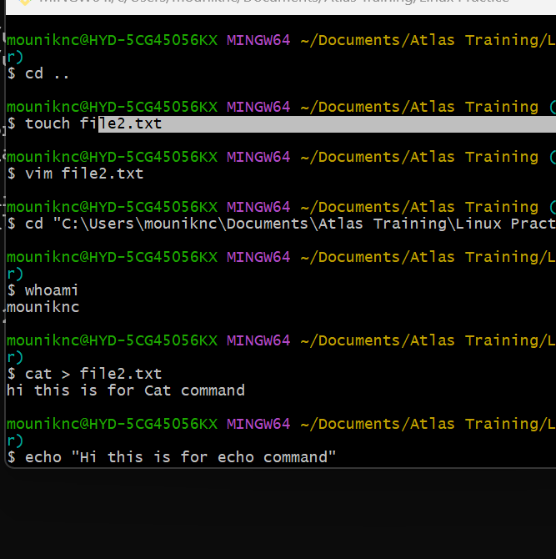

Who & w

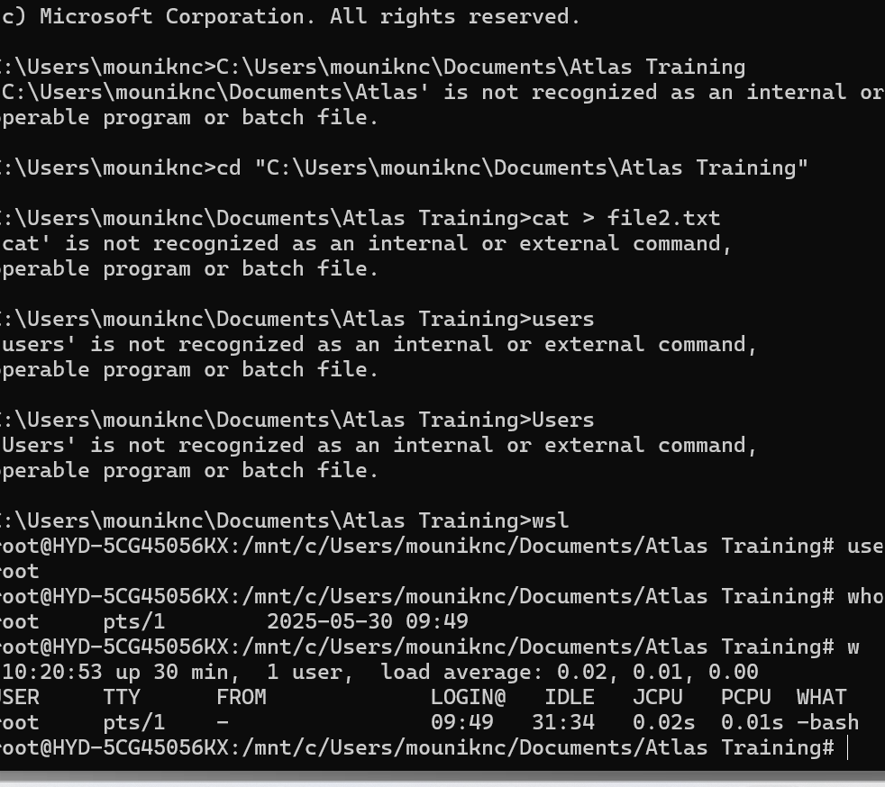

Disk space

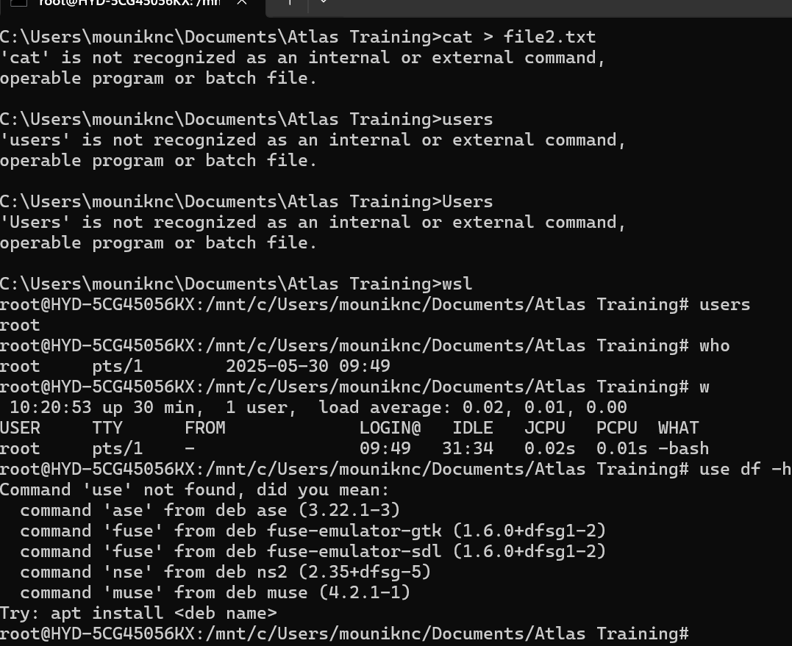

24:

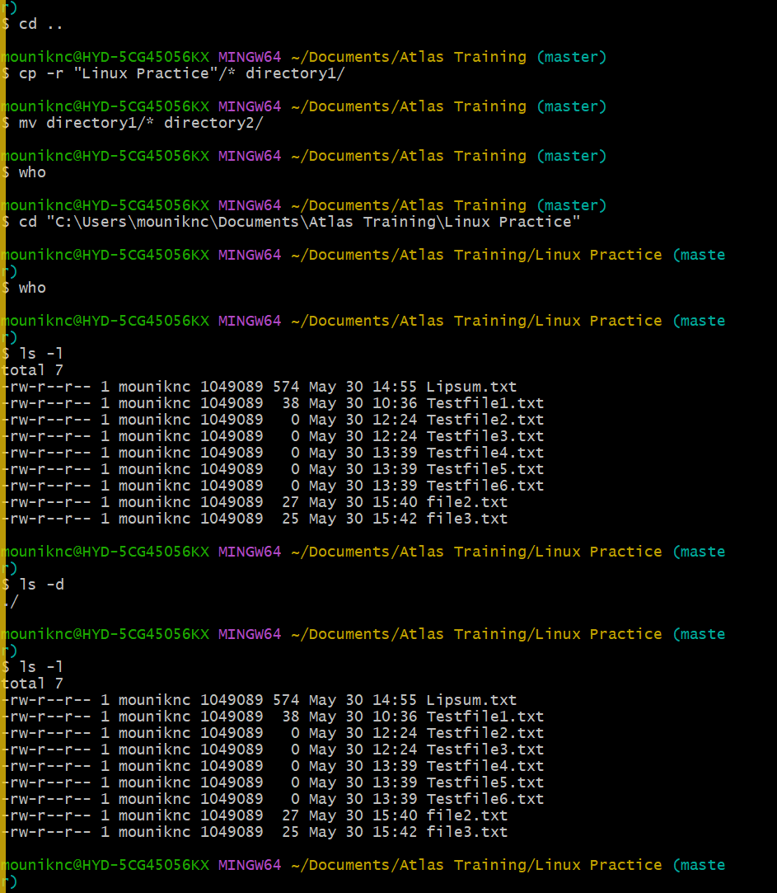

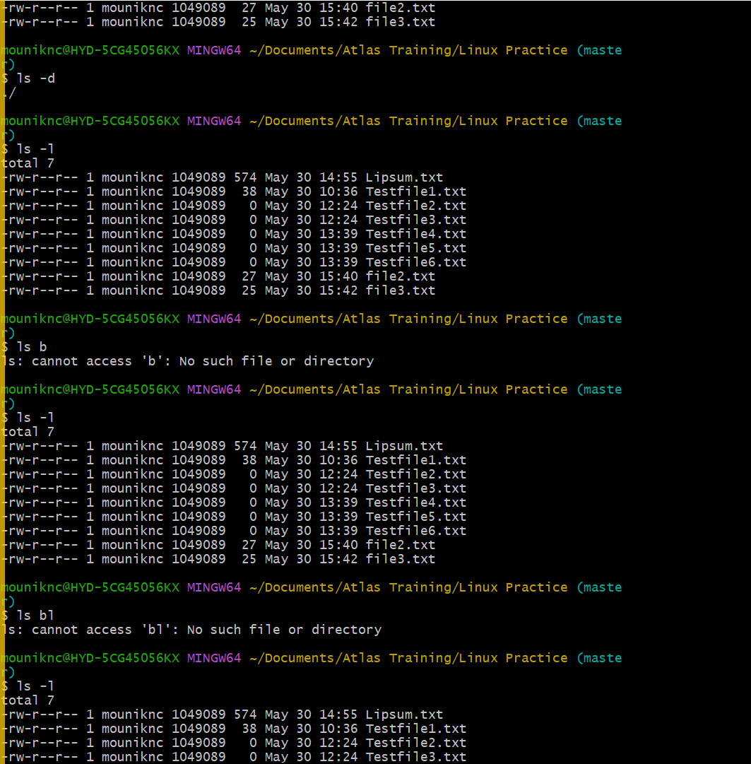

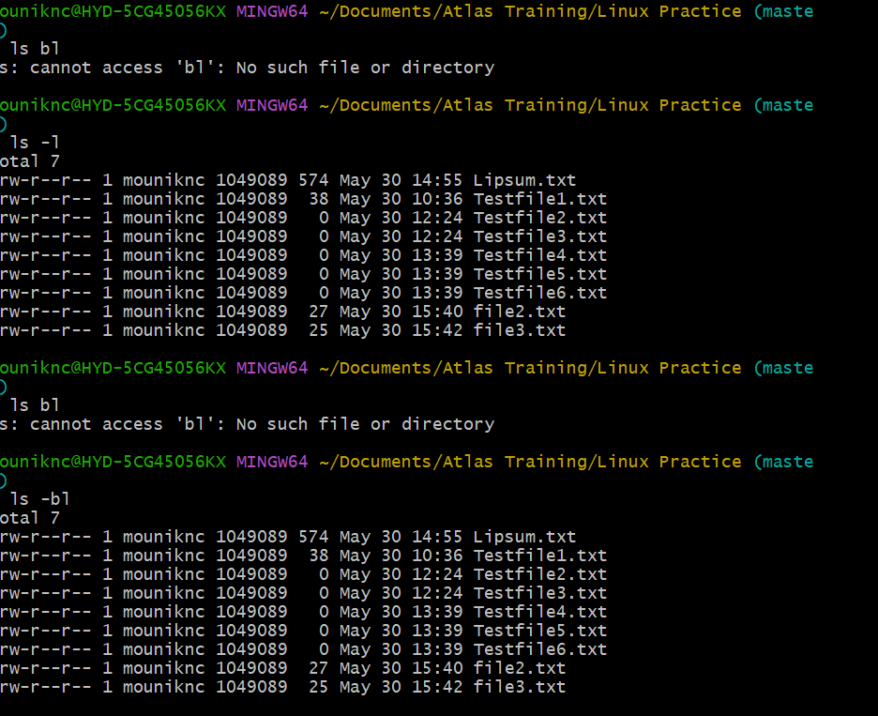

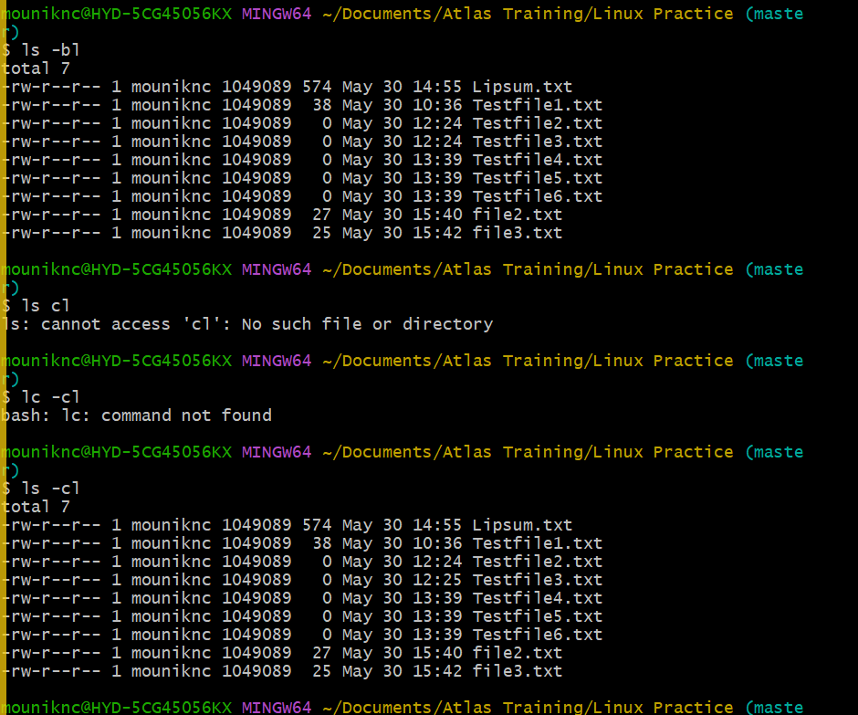

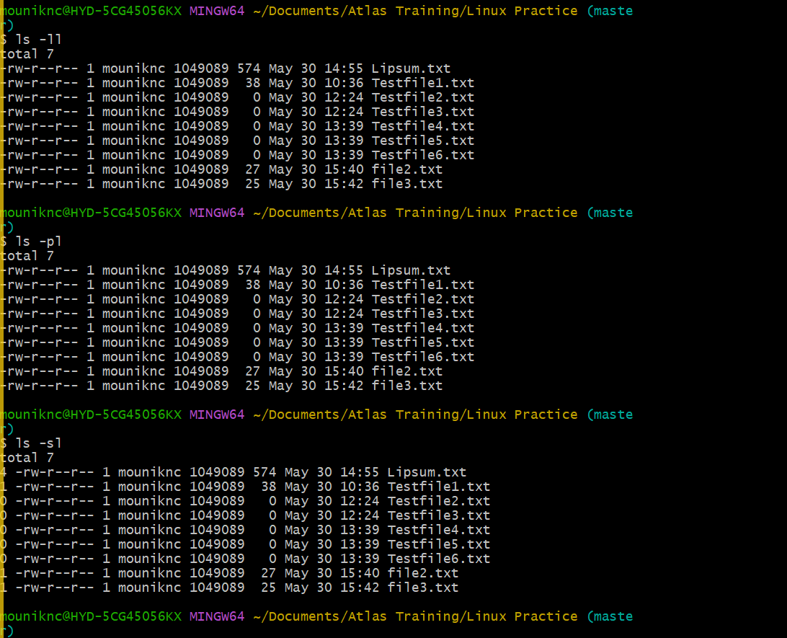

25:

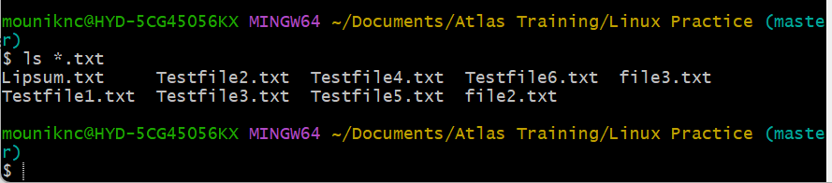

26:   
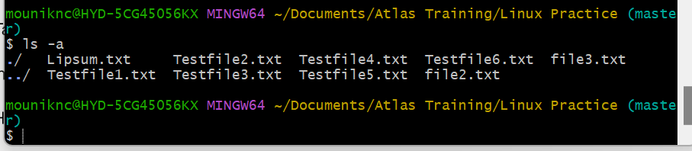

27:

1 - . refers to the current directory

2- .. refers to the parent directory.

28:

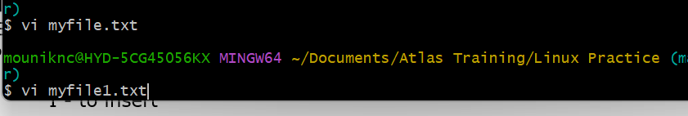

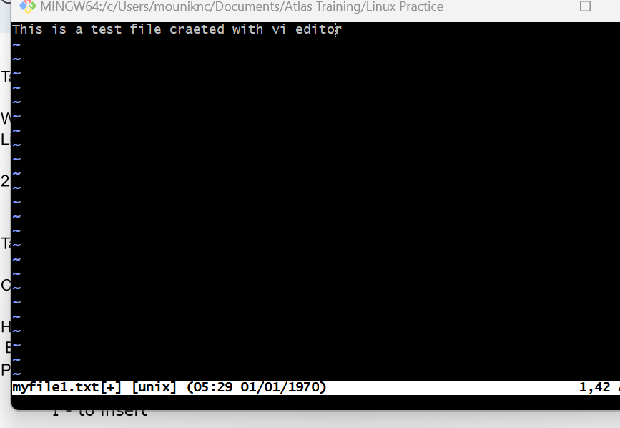

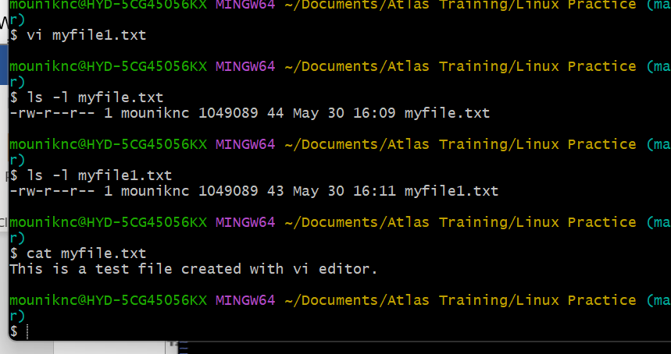

29:  
  
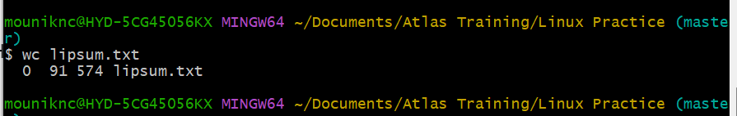

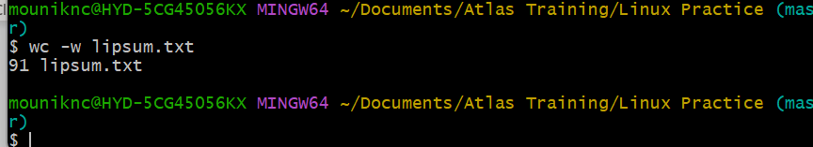

30. cat -b filename.txt – is used to display the contents of lipsum.txt with line numbers, but only for non-blank lines.

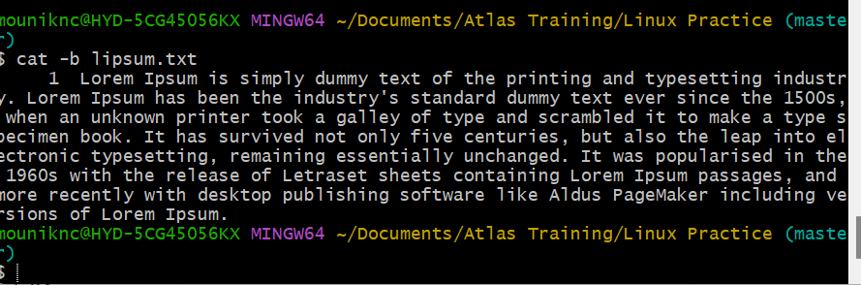

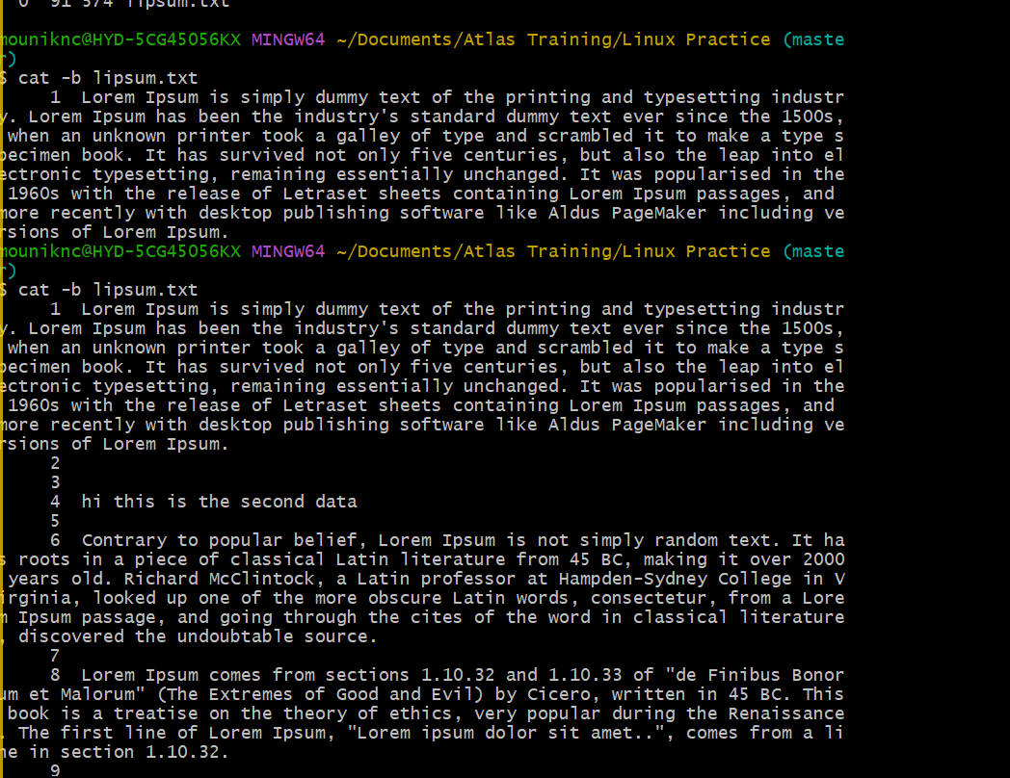

31.

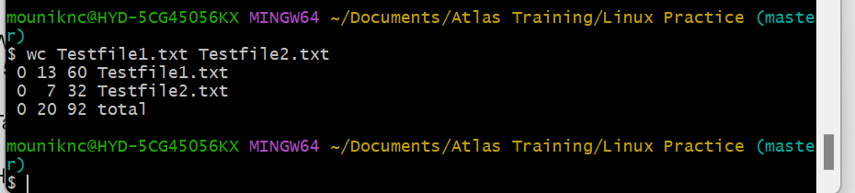

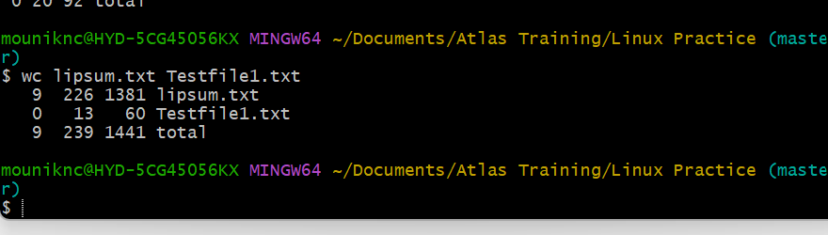

32:

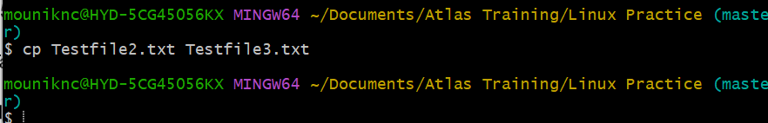

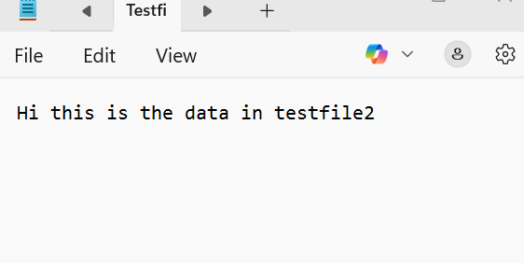

33:

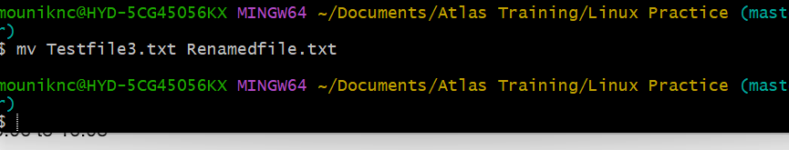

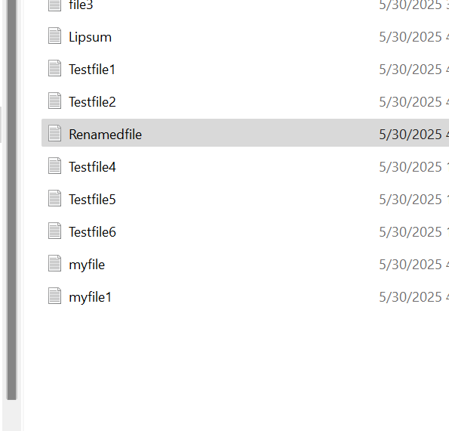

34:

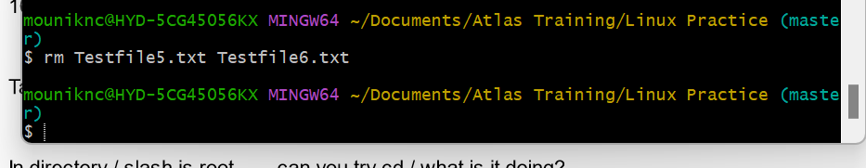

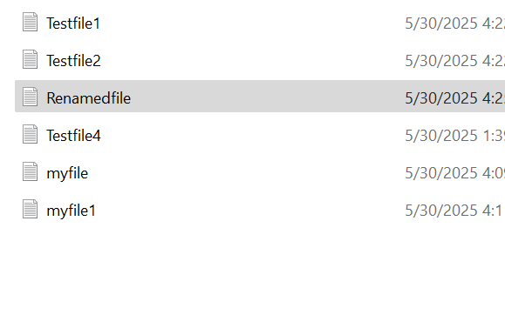

36:

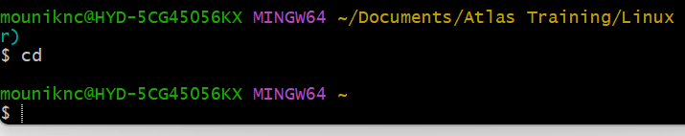

37:

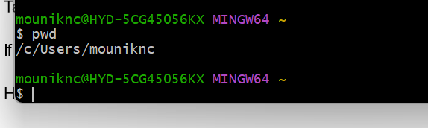

Users command – add user

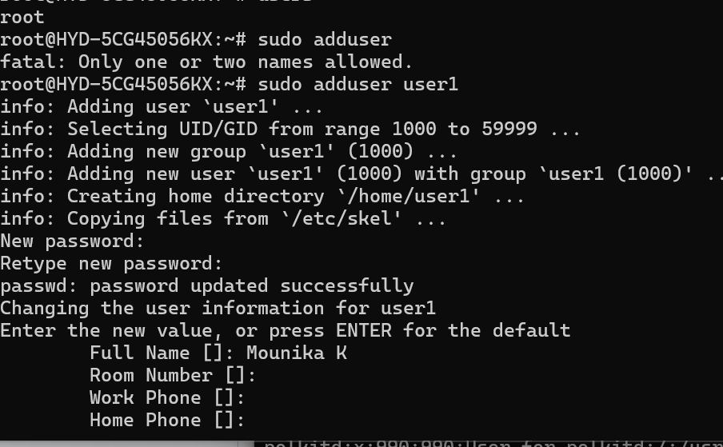

Chmods:  
